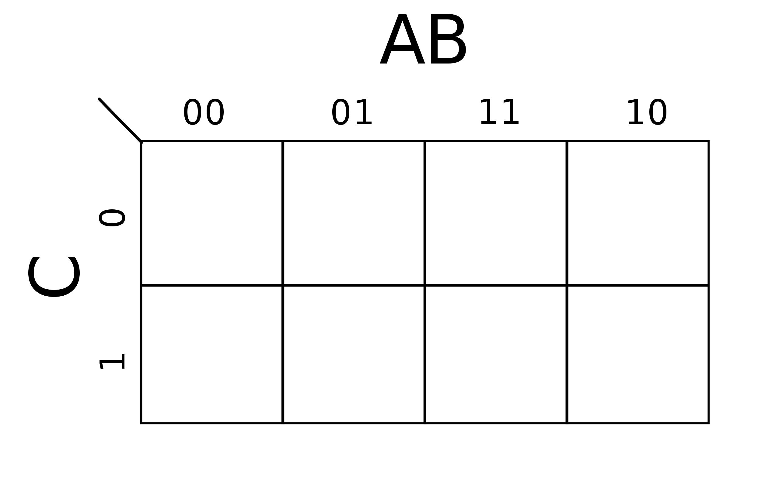
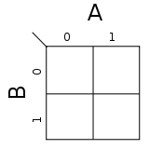
S-R D Flip-Flop - - - (SR = AB, Q = C)
0
0
0
D
x
1
x
1
J-K Variable Entered K-Map - - - (J = A, K = B)
Q
~Q
1
0
Q

